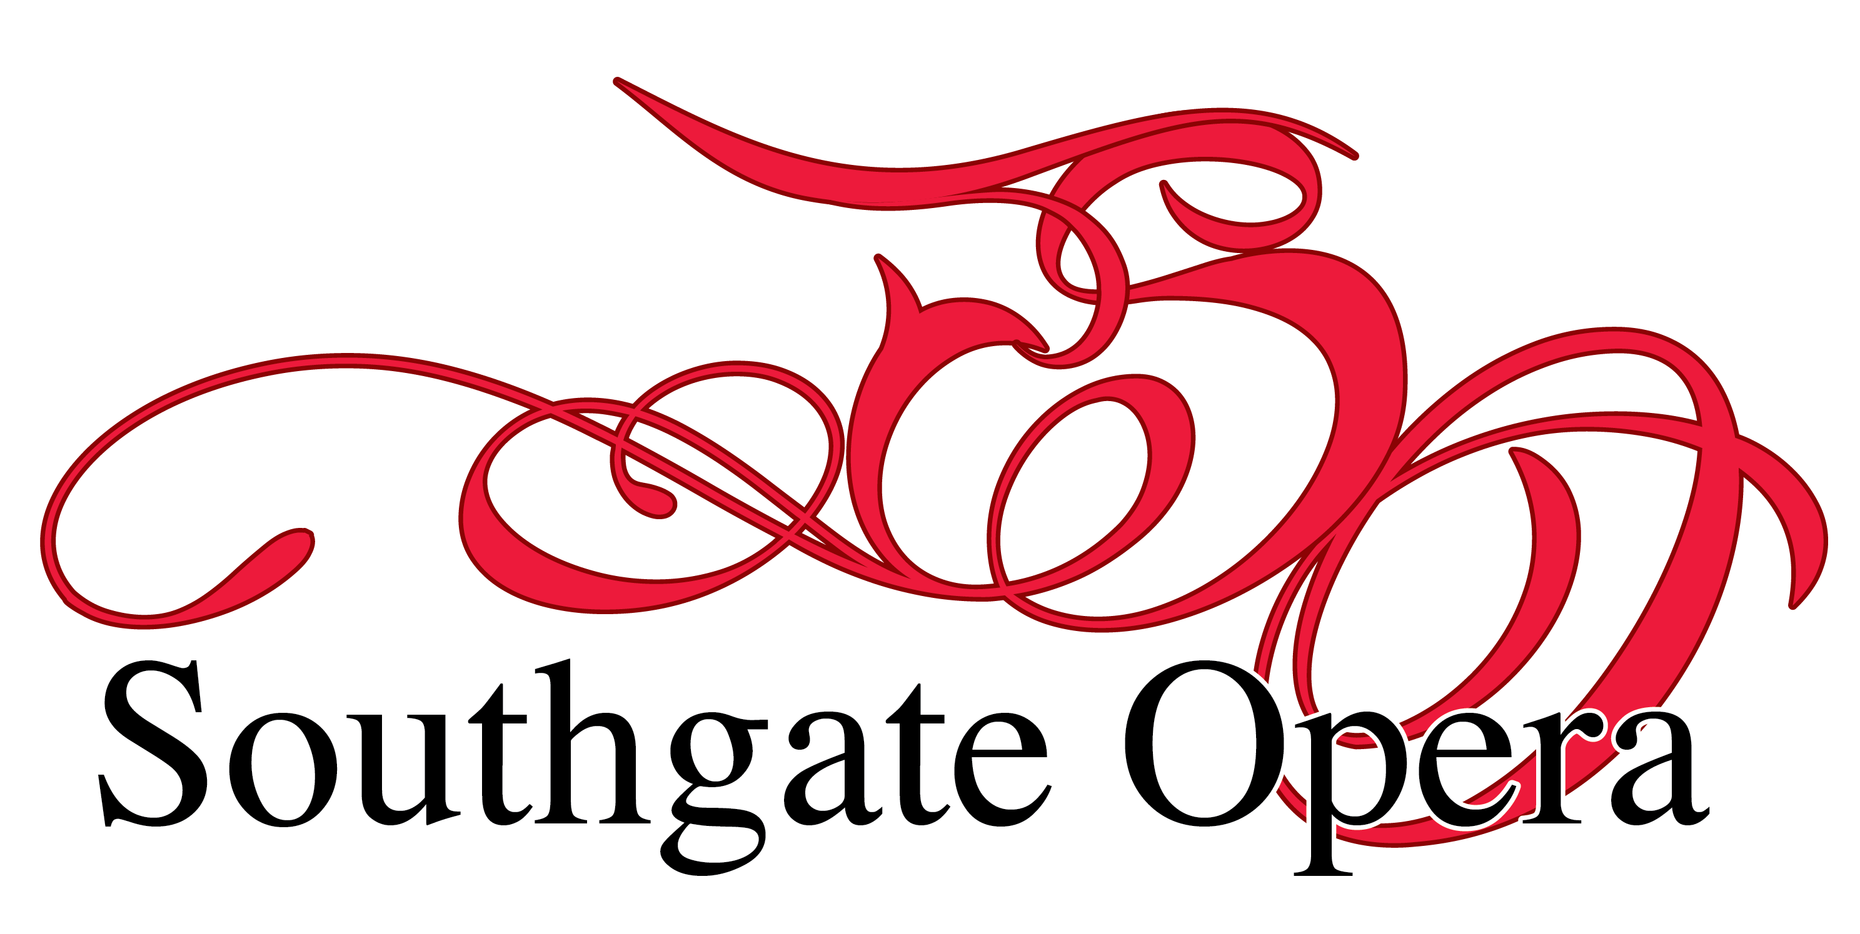
Audition Questionnaire

Please complete all sections of this form and return to:

Mike Gaughran, Auditions Co-ordinator, auditionsouthgate22@gmail.com

If you don’t have access to email call 020 8372 2383

Name: | Production:
Address: | Character/s auditioning for: (please state all characters you wish to be considered for)
Email: | Telephone No:

ALL AUDITION PIECES MUST BE SUNG IN ENGLISH

Please give details of musical experience or attach a CV:

Please state ALL commitments you may have with other companies, including rehearsals, during the rehearsal period for this production. If offered a part, you will be expected to attend all rehearsals, for which you are called, to be available for all the performance dates and to pay the appropriate fee.

If you are offered a role you will be asked at that point to state any dates you will not be available for rehearsal so that the rehearsal schedule can be drawn up. If extra N/As are given after the schedule is sent out, Southgate Opera reserves the right to recast your role if your N/As will disrupt rehearsals

Rehearsals are normally on Sundays 2.00-5.00pm for principals and on Mondays 7.30-10.00pm (principal and chorus)

Principals’ fees are up to £150 depending on the role, payable to Southgate Opera.

Data protection: Southgate Opera will use the details you have supplied on this form for the purposes of casting the show. We will not pass your details to other organizations without your permission. We will retain your details until the show is fully and finally cast.

If you would like us to retain your details beyond that for the purposes of informing you of future shows you might be interested in performing in, please tick this box. ☐

Please type or sign your name here to indicate you agree to pay the relevant fees in full and that you consent to being videoed (shows are usually videoed and offered for sale to those taking part)

Name: Date:

LATEST DATE FOR THE RETURN OF THIS FORM – 10 days before the audition date

